Name ______________________________ HOMEWORK Feb. 7-11
Put your initials by each night that your child practiced the following:
____Monday ____Tuesday ____Thursday
*Nightly Homework*
1. Count numbers 1-75.
2. Practice assigned Sight Word list in red reading folder.
MONDAY-Say the picture and listen for the last sound in the word. Circle the last sound in the word.
n l r | s g n | 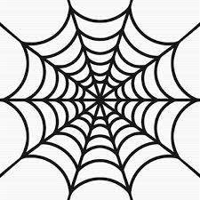  l g b | 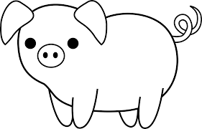  g r s | t m s

Write the letter.
Zz Zz Zz
Circle the pictures that begin with /z/.
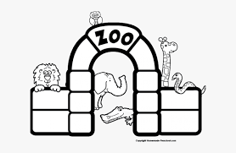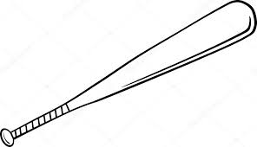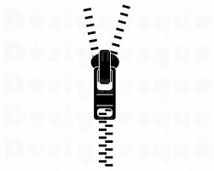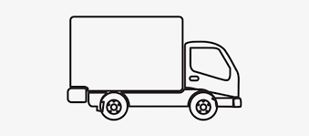

TUESDAY- Practice writing each spelling word three times.
set | bed | wet | jet | tub | pup | up
Label and draw three pictures that are in the -ack word family.
___ack | ___ack | ___ack

THURSDAY-Read the words.
get hot or where
hot or where get
or where get hot
where get hot or

Say each sound, then say it fast. Circle the picture for the word you say.
hen | 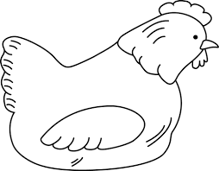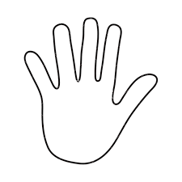
bed | 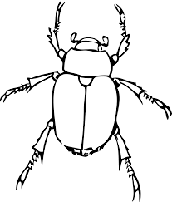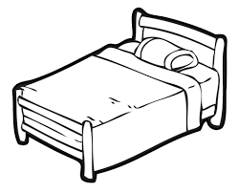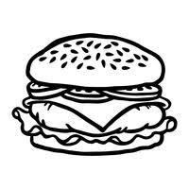
fan | 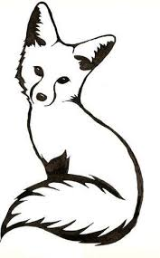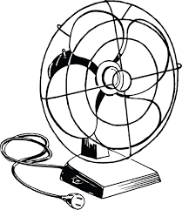

Start Right Reader Week of February 7-11
Directions: Let your child read this to you.

Words to Know
get hot
or

Quiz Us, Liz!
“Quiz us, Liz!” Liz nods. “It has six legs. It can run or hop.” “Is it a bug, Liz?” “Yes, Zac!” “It is hot. It is not dim. It can not run or hop.” “Is it the sun, Liz?” “Yes, Vin!” “Liz, let us quiz you!” “It can run or hop. It has zig zags. It is fun.” “Zac? Vin? I do not get it.” “It is you, Liz!”
Blend and Read: Read these words. Find these words in the story.
us yes six do
Liz quiz zig
zags Zac
stiff stuff

Initial each night.
Mon. | Tues. | Thurs.

